**BINDURA UNIVERSITY OF SCIENCE EDUCATION**

**FACULTY OF SCIENCES**



PEER TO PEER DELIVERY SYSTEM WITH BLOCKCHAIN

BY

BENEVOLENT MUDZINGANYAMA

B1851682

SUPERVISOR: MR CHAKA

***This dissertation is submitted in partial fulfillment of the requirements of the Bachelor of***

***Science honors degree in computer science***

**Abstract**

The rapid increase in digital transactions and online commerce has prompted the need of a faster and secure package delivery mechanism for businesses and individuals who make a living online. Over the years, the power of blockchain technology has been realized in economic, legal, logistics, security and many more sectors through the use of smart contracts and consensus algorithms. A Smart Contract is a digital agreement that binds two or more entities on a legal transaction. Blockchain is a distributed decentralized network that provides immutability, privacy, security, and transparency. There is no central authority present to validate and verify the transactions, yet every transaction in the Blockchain is considered to be completely secured and verified. This is possible only because of the presence of the consensus protocol which is a core part of any Blockchain network. A consensus algorithm is a procedure through which all the peers of the Blockchain network reach a common agreement about the present state of the distributed ledger. In this way, consensus algorithms achieve reliability in the Blockchain network and establish trust between unknown peers in a distributed computing environment.

An online delivery transaction is composed of the customer, seller, address (to/from) and date estimate for package arrival. However, due to a lack of technological means delivery has been a challenge in Zimbabwe. Some of the issues associated with the current methods are package theft, unreachable destinations, skeptics on trusting couriers, huge fees, and late deliveries. A peer to peer delivery network is a decentralized network of regular people serving as couriers to handle deliveries in transparent and secure manner.

This proposal is on the implementation of such system for package delivery, serving the the Zimbabwean populace. The proposed system utilizes the full potential of the blockchain technology to build a top-tier delivery system. The system encompasses a fusion of smart contracts, digital ledgers and consensus algorithms to provide trust, immutability, transparency and tracking features to the involved parties.

***Keywords: Blockchain, peer to peer, smart contracts, ledgers, consensus algorithm, block, logistics, delivery***

**DEDICATION**

This dissertation is dedicated to my parents, Mr and Mrs Mudzinganyama, who have always loved me unconditionally and whose good examples have taught me to work hard for the things that I aspire to achieve.

**ACKNOWLEDGEMENTS**

I would like to express my sincere thanks and gratitude to my supervisor, Mr Chaka for letting me work on this project. I am very grateful to him for his support and guidance in completing this project.

I am thankful to my parents as well. I was able to successfully complete this project with the help of their guidance and support. Finally, I want to thank all my dear friends as well

**TABLE OF CONTENTS**

**CHAPTER ONE: PROBLEM IDENTIFICATION……………………………………6**

**1.1 INTRODUCTION 6**

**1.2 BACKGROUND 6**

**1.3 STATEMENT OF THE PROBLEM 7**

**1.4 RESEARCH OBJECTIVES 8**

**1.5 RESEARCH QUESTIONS 8**

**1.6 RESEARCH HYPOTHESIS/PROPOSITIONS 8**

**1.7 JUSTIFICATION/SIGNIFICANCE OF THE STUDY 8**

**1.8 ASSUMPTIONS 9**

**1.9 LIMITATIONS/CHALLENGES 9**

**1.11 DEFINITION OF TERMS 10**

**CHAPTER TWO: LITERATURE REVIEW 11**

**2.1 INTRODUCTION 11**

**2.1.1 BLOCKCHAIN 13**

**2.1.2 CONSENSUS ALGORITHMS 17**

**2.1.3 LOGISTICS / DELIVERY 19**

**2.2 RELEVANT THEORY OF THE SUBJECT MATTER 20**

**CHAPTER THREE: RESEARCH METHODOLOGY 25**

**3.1 INTRODUCTION 25**

**3.1.2 RESEARCH DESIGN 25**

**3.1.3 DATA COLLECTION APPROACHES 26**

**INTERVIEWS 26**

**QUESTIONNAIRES 27**

**OBSERVATION 28**

**3.3 RESEARCH INSTRUMENTS 30**

**3.3.1 REQUIREMENT ANALYSIS 30**

**3.3.2 FUNCTIONAL REQUIREMENTS 30**

**3.3.3 NON-FUNCTIONAL REQUIREMENTS 30**

**3.3.4 HARDWARE REQUIREMENTS 31**

**3.3.5 SOFTWARE REQUIREMENTS 31**

**3.3.6 DESIGN TOOLS 32**

**3.4 DATA ANALYSIS PROCEDURES TO BE USED 32**

**3.4.1 SYSTEM DESIGN 33**

**3.4.1.2 DATA FLOW DIAGRAM 34**

**3.4.1.3 PROPOSED SYSTEM FLOW CHART 35**

**3.4.4 USE CASE DIAGRAM FOR THE PROPOSED SYSTEM 36**

**CHAPTER FIVE: CONCLUSIONS AND RECOMMENDATIONS 46**

**5.1 INTRODUCTION 46**

**5.2 MAJOR CONCULSIONS DRAWN 46**

**5.2.1 AIMS AND OBJECTIVES REALIZATION 46**

**5.2.2 CONCLUSIONS 46**

**5.5 CHALLENGES FACED 47**

**APPENDIX 48**

**REFERENCES 50**

**CHAPTER 1: INTRODUCTION**

**1.1 INTRODUCTION**

One important aspect of running an online company that one must get right is delivery. The needs of customers have significantly changed, and the majority now demand a quick, dependable delivery service. Goods used to be delivered in 7-10 working days, with very few options available to customers. However, as technology has advanced, so has the number of available delivery methods and options.

Customers today have numerous options for receiving the goods they purchase online. This has resulted in a complete shift in attitude toward how delivery should function. Next-day deliveries are no longer a luxury; they are expected. As a result, if a company does not offer a variety of delivery options, it may be missing out on a large number of potential customers.

Delivery is also the customer's last impression of your company. So, if they have a problem, it will give them an unfavourable impression of your brand, and they will be hesitant to buy from you again.

## **1.2 BACKGROUND**

The recent pandemic, Covid-19 , gave a rapid boost to the online business community which has been struggling to assert dominance over physical stores in Zimbabwe.

Since most stores were operating and providing their services in-person, there has never been an issue with home deliveries since customers would just buy and collect their purchase on their own. For those businesses who offer deliveries to customers who might not have the means to collect their purchase, late and dissatisfaction from the delivery services is always to be expected as they consider it an afterthought; nothing more than a piece of admin to tie up the loose ends after a sale has been made.

With the rise of online commerce during the pandemic and past it, customers can just fire up their devices, get to the seller’s website, add a couple items to the cart, go to checkout, and that’s it, a purchase is made. It is however, after a purchase of a product is completed that a new problem would emerge, that is the painstaking delivery process. Most companies and customers do not usually think past delivery when it comes to shopping and selling online but in truth it is a huge hurdle that might sour the fun experience of shopping at home, that is the flexibility of shopping at any given time of the day and from any location around the globe.

Assuming that the distance between the customer and seller is huge and the seller is just a small business with limited resources to cater for long distance deliveries, but both want a favourable outcome after conducting businesses with each other, for example a seller operates from Harare and the customer is from Gokwe. Without a (good) delivery mechanism, the transaction would strain both parties, either financially if they agree to proceed or the customer might loose interest and choose another seller with a viable delivery service, who might be outsourcing from known logistics companies such as FedEx or Cheetah Express.

Furthermore, the problem with trusting a logistics company to handle deliveries, now comes from the lack of transparency and the time it will take to get the package delivered will also constitutes to higher fees from the respective company. Also it is of note that, most collaboration with these third parties is conducted manually and offline, which often leads to redundancies and mistakes. The involvement of long and complex supply chains involving multiple organizations will brought about lack of trust among the parties involved, high delivery costs and lack of end-to-end transparency caused by a restricted flow of information and generally awfully slow deliveries.

Efficiency will only be possible if there was process that could cut all the intermediaries and provide a faster reliable delivery service to customers, thereby making the overall online shopping, a glorious experience for everyone.

## **1.3 STATEMENT OF THE PROBLEM**

For a product to reach the customer from the seller, the delivery procedure in online commerce has been connected with extensive and complicated supply chains including a large number of middlemen. There is little to no end-to-end transparency as a result of logistics businesses restricting information flow, leaving both the vendor and client in the dark throughout the process. A trust deficit is to be expected in a system like this, because the logistics business might change information or anything else in transit before the shipment reaches its owner.

## **1.4 RESEARCH OBJECTIVES**

* To design and develop a blockchain system which allow peer to peer deliveries.
* To implement blockchain technology through use of smartcontracts and consensus algorithms for peer to peer delivery transaction validation, trustworthy and verification.
* To evaluate delivery transaction traceability and transparency

## **1.5 RESEARCH QUESTIONS**

* How does the system allows peer to peer deliveries?
* To what extent do blockchain algorithms archive delivery transaction validation, trustworthy and verification.
* How does the system evaluate delivery transaction traceability and transparency?

## **1.6 RESEARCH HYPOTHESIS/PROPOSITIONS**

**Null Hypothesis (H0):** The use of a blockchain aided peer to peer delivery system reduces complexity, improve transparency and boost trust in the delivery process

**Alternative Hypothesis (H1):** The use of a blockchain aided peer to peer delivery system does not reduces complexity, improve transparency and boost trust in the delivery process.

## **1.7 JUSTIFICATION/SIGNIFICANCE OF THE STUDY**

There is a rapid increase of mobile device and internet users which is prompting the need for many companies to put their businesses online, and let their customer base or potential customers discover them quickly, making it easy to buy any product from any location at any given time. The projection of online shoppers has been steadily increasing in developing countries such as Zimbabwe, giving equal access to products without location barriers.

However, then arise the need to get goods delivered to geographically distanced locations from the origin and that process is becoming increasingly complex, with more parties directly or indirectly involved in the supply chains. This complexity is creating challenges related to communication and end-to-end visibility making logistics processes inefficient. At the same time expectations of all participants in the supply chain related to transparency, reliability and service are increasing.

These issues are addressed with the use of blockchain’s technology features, which includes smart contracts, immutable ledgers, cryptographic functions and distributed blocks of information.

## **1.8 ASSUMPTIONS**

The research project was carried out on the following assumptions:

* All delivery requests are from online users
* Payments are already made to the sellers before delivery began
* The are already registered users on the system to facilitate peer to peer delivery
* Payment for deliveries is done before the process begins
* Addresses of close peers is already known

## **1.9 LIMITATIONS/CHALLENGES**

* The system will only serve online users who posses at least a mobile device or a computer.
* Only after a larger amount of users are registered on the system will it prove its usefulness for peer to peer collaboration
* The consensus algorithm consumes a lot of computing resources that will require expensive equipment to implement the system on a full scale level

**1.10 SCOPE/DELIMITATION OF THE RESEARCH**

The study will focus on the use of blockchain and primarily, its consensus algorithms and smartcontracts in the delivery processes for internet users who practice online shopping in Zimbabwe.

## **1.11 DEFINITION OF TERMS**

**Blockchain** - A blockchain is a digitally distributed, decentralized, public ledger that exists across a network

**Block** - Blocks are data structures within the blockchain database, where transaction data is permanently recorded.

**Smart Contracts** - A smart contract is a self-executing contract with the terms of the agreement between buyer and seller being directly written into lines of code.

**Peer** - A peer is a trusted user who is on a blockchain network. It could mean a known associate or a stranger with common goals with another stranger

**Ledger** - Is an immutable collection of transaction data

**Nodes** - A node mean a computer or device that is connected on the blockchain

**Proof of Wor**k - It is a form of cryptographic proof in which one party proves to others that a certain amount of a specific computational effort has been expended.

**Miners** - Self aware machines or persons who validates all the transactions added onto the blockchain

# **CHAPTER TWO: LITERATURE REVIEW**

## **2.1 INTRODUCTION**

This chapter aims to shade light on previous attempts on the use of blockchain in logistics processes including in the supply chain management. It will also dive into some of the most popular algorithms and logistics processes that are essential in the creation of the proposed delivery system.

Many projects are underway using blockchain technology to improve supply chain transparency and monitor provenance. These initiatives amass data about how goods are made, where they come from, and how they are managed; this information is stored in the blockchain-based system. This means that the data becomes permanent and easily shared, giving supply chain players more comprehensive track-and-trace capabilities than ever before.

Companies can use this information to provide proof of legitimacy for products in pharmaceutical shipments, for example, and proof of authenticity for luxury goods. These initiatives also deliver consumer benefits – people can find out more about the products they are buying, for example, whether a product has been ethically sourced, is an original item, and has been preserved in the correct conditions

**Since** many e-commerce companies relies on the dependability of a reliable delivery system, many articles were published on the possibility of getting blockchain embedded on logistics processes for delivery purchased goods more efficiently. These studies, and some of the early implementations are of greater importance to the proposed system as they motivate this study.

Overly the literature review will address or be focused on answering the following questions bellow:

1. What knowledge or what do we know about the use of blockhain technology in the logistics industry?
2. What are the existing researches on blockchain the logistics industry?
3. The contribution the pre-set study is yet to bring.

The proposed system addressed the most common outcomes (above) and move further to a new way of logistics through the technologies features which allow the peer to peer collaboration on a larger scale, thereby making the whole process reliable and cost efficient.

**2.1.1 BLOCKCHAIN**

Blockchains are ledgers that record transactions in a trustless environment and are

protected by the science of cryptography. A finite set of transactions is placed on each block, which is protected by digital signatures and cryptographic hash functions. Using the hash of the immediate preceding block, the next block makes a link with this preceding block. With blockchain technology there is no need for a third party to verify the transactions; indeed, this verification is decentralised and performed by the nodes connected to each block. A node is a client on the blockchain that has a copy of the same blockchain and can add data to the blockchain. To create a valid digital signature for each user on blockchain that cannot be forged, each user is given a public key and a private key. (Christidis and Devetsikiotis, 2016) provide further details on how users of blockchains interact and reach consensus. Some of the main

features of blockchains are that they are immutable, transparent, secure, decentralised,

irreversible and based on consensus (Babich and Hilary, 2018).

**BLOCKHAIN ARCHITECTURE**

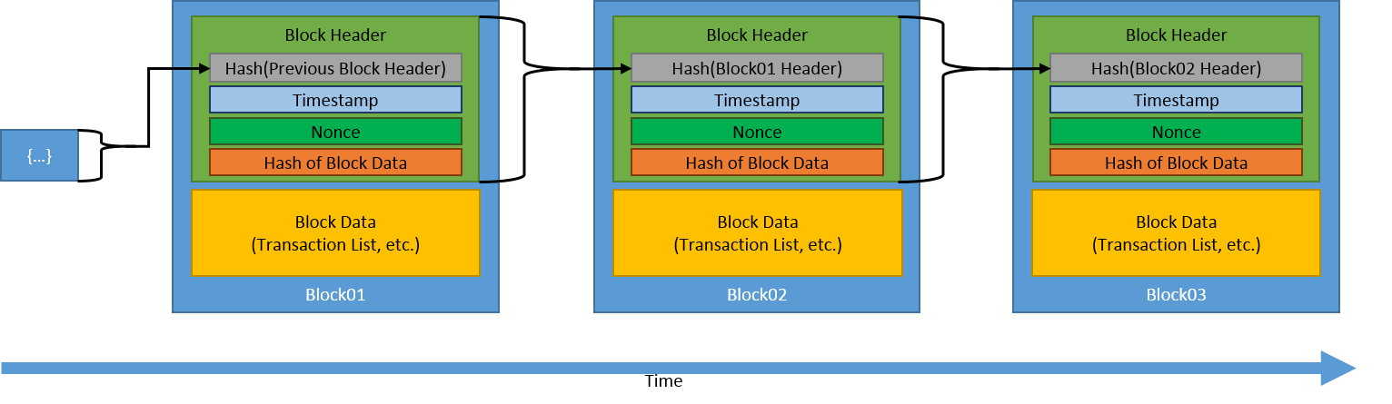

***Figure 1***

**BLOCK**

A block consists of the block header and the block body as shown in Figure 2. In particular, the block header includes:

* Block version: indicates which set of block validation rules to follow.
* Parent block hash: a 256-bit hash value that points to the previous block.
* Merkle tree root hash: the hash value of all the transactions in the block.
* Timestamp: current timestamp as seconds since 1970-01-01T00:00 UTC.
* nBits: current hashing target in a compact format.
* Nonce: a 4-byte field, which usually starts with 0 and increases for every hash
* calculation (will be explained in details in Section 3).

The block body is composed of a transaction counter and transactions. The maximum

number of transactions that a block can contain depends on the block size and the size of each transaction. Blockchain uses an asymmetric cryptography mechanism to validate the authentication of transactions (NRI, 2015). A digital signature based on asymmetric cryptography is used in an untrustworthy environment. We next briefly illustrate digital signature.

**DIGITAL SIGNATURE**

Each user owns a pair of private key and public key. The private key is used to sign the transactions. The digital signed transactions are spread throughout the whole network and then are accessed by public keys, which are visible to everyone in the network. Figure 3 shows an example of digital signature used in blockchain. The typical digital signature is involved with two phases: the signing phase and the verification phase. Take Figure 3 as an example again. When a user Alice wants to sign a transaction, she first generates a hash value derived from the transaction. She then encrypts this hash value by using her private key and sends to another user Bob the encrypted hash with the original data. Bob verifies the received transaction through the comparison between the decrypted hash (by using Alice’s public key) and the hash value derived from the received data by the same hash function as Alice’s. The typical digital signature algorithms used in blockchains include elliptic curve digital signature algorithm (ECDSA) (Johnson et al., 2001).

Figure 3: Digital signature used in blockchain

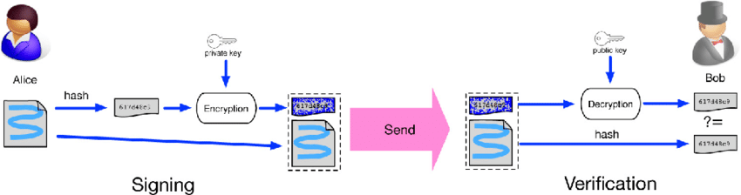

***Figure 2***

**KEY CHARACTERISTICS OF BLOCKCHAIN**

In summary, blockchain has following key characteristics.

* Decentralisation. In conventional centralised transaction systems, each transaction needs to be validated through the central trusted agency (e.g., the central bank) inevitably resulting the cost and the performance bottlenecks at the central servers. Differently, a transaction in the blockchain network can be conducted between any two peers (P2P) without the authentication by the central agency. In this manner, blockchain can significantly reduce the server costs (including the development cost and the operation cost) and mitigate the performance bottlenecks at the central server.
* Persistency. Since each of the transactions spreading across the network needs to be confirmed and recorded in blocks distributed in the whole network, it is nearly impossible to tamper. Additionally, each broadcasted block would be validated by other nodes and transactions would be checked. So any falsification could be detected easily.
* Anonymity. Each user can interact with the blockchain network with a generated address. Further, a user could generate many addresses to avoid identity exposure. There is no longer any central party keeping users’ private information. This mechanism preserves a certain amount of privacy on the transactions included in the blockchain. Note that blockchain cannot guarantee the perfect privacy preservation due to the intrinsic constraint
* Auditability. Since each of the transactions on the blockchain is validated and recorded with a timestamp, users can easily verify and trace the previous records through accessing any node in the distributed network. In Bitcoin blockchain, each transaction could be traced to previous transactions iteratively. It improves the traceability and the transparency of the data stored in the blockchain.

**TAXONOMY OF BLOCKCHAIN SYSTEMS**

Current blockchain systems can be roughly categorised into three types: public blockchain, private blockchain and consortium blockchain (Buterin, 2015).

* Consensus determination. In public blockchain, each node could take part in the consensus process. And only a selected set of nodes are responsible for validating the block in consortium blockchain. As for private chain, it is fully controlled by one organisation who could determine the final consensus.
* Read permission. Transactions in a public blockchain are visible to the public while the read permission depends on a private blockchain or a consortium blockchain. The consortium or the organisation could decide whether the stored information is public or restricted.
* Immutability. Since transactions are stored in different nodes in the distributed network, so it is nearly impossible to tamper the public blockchain. However, if the majority of the consortium or the dominant organisation wants to tamper the blockchain, the consortium blockchain or private blockchain could be reversed or tampered.
* Efficiency. It takes plenty of time to propagate transactions and blocks as there are a large number of nodes on public blockchain network. Taking network safety into consideration, restrictions on public blockchain would be much more strict. As a result, transaction throughput is limited and the latency is high. With fewer validators, consortium blockchain and private blockchain could be more efficient.
* Centralised. The main difference among the three types of blockchains is that public blockchain is decentralised, consortium blockchain is partially centralised and private blockchain is fully centralised as it is controlled by a single group.
* Consensus process. Everyone in the world could join the consensus process of the public blockchain. Different from public blockchain, both consortium blockchain and private blockchain are permissioned. One node needs to be certificated to join the consensus process in consortium or private blockchain.

**2.1.2 CONSENSUS ALGORITHMS**

In blockchain, how to reach consensus among the untrustworthy nodes is a transformation of the Byzantine Generals (BG) Problem (Lamport et al., 1982). In BG problem, a group of generals who command a portion of Byzantine army circle the city. The attack would fail if only part of the generals attack the city. Generals need to communicate to reach an agreement on whether attack or not. However, there might be traitors in generals. The traitor could send different decisions to different generals. This is a trustless environment. How to reach a consensus in such an environment is a challenge. It is also a challenge for blockchain as the blockchain network is distributed. In blockchain, there is no central node that ensures ledgers on distributed nodes are all the same. Nodes need not trust other nodes. Thus, some protocols are needed to ensure that ledgers in different nodes are consistent. We next present several common approaches to reach consensus in the blockchain.

**PROOF OF WORK**

Consider Bitcoin as an example of a cryptocurrency system secured with a proof of work algorithm. Each block in Bitcoin have two parts:

* block header of key parameters, including block creation time, reference to the previous block and the Merkle tree root of the block of transactions;
* block list of transactions.

To reference a specific block, its header is hashed twice with the SHA-256 function; the resulting integer value belongs to the interval [0, 2256 − 1]. Using a generic hashing function - hash(·) with a variable number of arguments and range [0, M] will be without binding to the particular algorithm.

The block reference is used in the proof of work protocol; in order for a block to be considered valid, its reference must not exceed a certain threshold:

Hash (Block) ≤ M/D (1)

where D M ∈[1, ] is the target difficulty. The only way to find Block satisfying iterate through all possible variables in the block header repeatedly. The higher the value of difficulty, the more iterations are needed to find a valid block; the expected number of operations is exactly difficulty.

The time period T(r) for a miner with hardware capable of performing k operations per second to find a valid block is distributed exponentially with the rate k/D:

P { T(k) ≤ t } = 1 – exp(-kt/D)

Consider n Bitcoin miners with hash rates k1, k2, …,kn. The period of time to find a block T is equal to the minimum value of random variables T(ki) assuming that the miner publishes a found block and it reaches other miners immediately. According to the properties of the exponential distribution, T is also distributed exponentially:

P { T def = min (T1, . . . , Tn) ≤ t } = 1 – exp( -t D ∑n i=1 ki )

P { T = Ti } = ki / ∑j=1n kj

The last equation shows that the mining is fair: a miner with a share of mining power p has the same probability p to solve a block before other miners.

**PROOF OF STAKE**

In proof of stake algorithms, inequality is modified to depend on the user’s ownership of the cryptocurrency and not on block properties. Consider a user with

address A and balance - balance(A). A commonly used proof of stake algorithm uses a conditions[9]

Hash( Hash( Blockprev), A, time) ≤ balance(A) M / D

where

* Blockprev denotes the block the user is building on,
* time is the current UTC timestamp.

Unlike, the only variable that the user can change is the timestamp t in the left part of the equation. The address balance is locked by the protocol; e.g., the protocol may calculate the balance based on funds that did not move for a day. There are no expensive computations involved in the proof of stake. Together with an address A and a timestamp t satisfying, a user must provide a proof of ownership of the address. To achieve this, he must have a private key corresponding to the address A. The time to find a block for address A is exponentially distributed with rate bal(A)/D. Consequently, the implementation of proof of stake is fair: the probability to generate a valid block is equal to the ratio of user’s balance of funds to the total amount of currency in circulation. The time to find a block for the entire network is distributed exponentially with rate ∑a bal(a)/D.

**DELEGATED PROOF OF STAKE**

Delegated proof of stake (DPoS) is a generic term describing an evolution of the basic PoS consensus protocols. Blocks are minted by a predetermined set of users of the system (delegates), who are rewarded for their duty and are punished for malicious behavior (such as participation in double-spending attacks). In DPoS algorithms, delegates participate in two separate processes:

* building a block of transactions;
* verifying the validity of the generated block by digitally signing it.

While a block is created by a single user, to be considered valid, it typically needs to be signed by more than one delegate. The list of users eligible for signing blocks is changed periodically using certain rules. The set of delegates for each block is typically small. In some DPoS versions, a delegate needs to show commitment by depositing his funds into a timelocked security account (which is confiscated in case of malicious behavior); this version of DPoS is often referred to as deposit-based proof of stake. The stake is factored into DPoS with one of the following methods:

* delegates may be elected based on their stake in the system;
* delegates may receive votes from all users of the system with voting power depending on a voter’s stake;
* delgates’ votes on valid blocks may have power proportional to the size of their security deposit

**2.1.3 LOGISTICS/DELIVERY**

If Supply Chain Management is an integrating function with primary responsibility for linking business functions within and across companies into a cohesive and high performing business model, Logistics is considered by the different actors as the ‘‘reason to be’’ of each firm belonging to a supply chain. Without logistics, no raw material can be extracted, transformed and delivered to the final user.

Logistics is evolving rapidly in the past decade, thanks to the introduction of new management frameworks, as the Physical Internet and Industry 4.0, and new technologies, mainly ICT-based, as the Internet of Things (IoT), Business Analytics, Artificial Intelligence, and Blockchain companies. The Blockchain is one of the most promising technologies in Logistics Management and Optimization, thanks to some intrinsic characteristics, as data integrity and decentralized operations. But how to incorporate a Blockchain in a real Logistic system, and how and when this marriage might be fruitful are still open questions. In the following, we give a quick depiction of the requirements of a modern Supply Chain, the characteristics attributed to a Blockchain system and finally, we discuss the issues related

to the scalability and the costs of the technology itself.

**2.2 RELEVANT THEORY OF THE SUBJECT MATTER**

**2.2.1 DIFFUSION OF BLOCKCHAIN IN LOGISTICS AND TRANSPORTATION INDUSTRY: AN ANALYSIS THROUGH THE SYNTHESIS OF ACADEMIC AND TRADE LITERATURE**

Blockchain technology has fascinated researchers and industry professionals. Since its birth, the attention for blockchain has been exponentially increasing, however, most of the industries are still skeptical in adoption for value creation. The purpose of this study is to analyze the actual level of implementation and diffusion of blockchain technology within the logistics and transportation industry by comparing and using the collective intelligence of academic literature and industry practices of implementation of blockchain in this domain.

The authors (Anuj Batta, *et al..,* 2020) used the methodology of systematic literature review along with inductive reasoning. The systematic literature review of academic and industry frontiers together has brought a bigger and real picture into consideration. The results highlight that, within the transportation sector, currently there is a very low diffusion of blockchain, although applications show immense promises for the future. The various application where blockchain technology can make a significant impact are also identified.

**2.2.2 BLOCKCHAIN FOR SECURING SUSTAINABLE TRANSPORT CONTRACTS AND SUPPLY CHAIN TRANSPARENCY**

The author (Amina Badzar, 2016), explore the potential application of blockchain in the field of logistics in regard to supply chain transparency and transport contract fulfilment concerning sustainability clauses. The research is conducted through a case study approach, combined with a literature review and a semi-structured interview with an expert with in the field of blockchain technology. The study has the potential to empower the position of consumers, suppliers and manufacturers regarding knowledge about the product and the social and environmental activities associated with the products supply chain. Findings show that the implementation of blockchain in logistics can potentially generate more awareness about the hidden layers of the

supply chain, and global transportation. The results could contribute to improving service management within companies and improve their policies concerning sustainability and environmental impacts. The thesis contributes to the expanding research field of blockchain technology within logistics.

**2.2.3 BLOCKCHAIN TECHNOLOGY IN LOGISTICS AND SUPPLY CHAIN MANAGEMENT—A BIBLIOMETRIC LITERATURE REVIEW FROM 2016 TO JANUARY 2020**

As part of business and management studies, research works addressed blockchain technology (BCT) in logistics and supply chain management (LSCM) first in 2016. Increasing levels of interest from researchers and practitioners alike have led to an increasing number of studies from both ends; however, a thorough bibliometric- and cocitation network analysis of BCT in LSCM research has not been carried out so far.

To address this gap and to build a basis for future research endeavors, the authors (Benjamin Müßigmann, *et al…*, 2020) article provides a bibliometric analysis on BCT, comprising data from 613 articles from academic supply chain research. It is therefore an easy-to-access entry point for academics and practitioners into the topic of BCT in LSCM. This study aims to understand the status of research of BCT in LSCM. To present the results, this article employs a bibliometric analysis methodology. It adopts a citation network analysis and a cocitation analysis. Based on a cocitation analysis, this article classifies the existing literature into five different research clusters, including theoretical sensemaking, conceptualizing and testing blockchain applications, framing BCT into supply chains, the technical design of BCT applications for real-world LSCM applications, and the role of BCT within digital supply chains.

**2.2.4 BLOCKCHAIN IN BIG DATA SECURITY FOR INTELLIGENT TRANSPORTATION WITH 6G**

The authors (Zhili Zhou, *et al…,* 2022) investigated how blockchain can solve the security problems in Intelligent Autonomous Transport System (IATS) and intelligentize the logistics transportation development. Regarding the scarcity of trust and concentration of rights caused by the centralized structure of traditional logistics information systems, a blockchain-based IATS is proposed. The system employs Ethereum as the underlying blockchain to record sensitive information, such as system orders, cargo, and personnel information on the blockchain, ensuring the non-tampering and credibility of data. Simultaneously, an order management module, a warehouse management module, a transportation management module, a transaction management module, and a system management module are established. In the meantime, the Light Gradient Boosting Machine (LightGBM) algorithm is utilized to recommend vehicle and cargo matching during transportation. Finally, the constructed algorithm model is simulated to analyze its performance. Results demonstrate that the security prediction accuracy of the proposed algorithm reaches 88.72%; moreover, the security prediction precision, recall, and F1 of the proposed algorithm are considerably better than those of other algorithms. Furthermore, the actual effect of each algorithm is analyzed. The LightGBM algorithm outperforms other algorithms and unused algorithms in click rate, conversion rate, turnover rate, and average response time. Therefore, the constructed blockchain-based IATS has excellent security performance and prediction accuracy, which provides an experimental basis for the later intelligent logistics transportation development.

**2.2.5 BLOCKCHAIN CHALLENGES AND OPPORTUNITIES: A SURVEY**

The authors (Zibin Zheng and Shaoan Xie, 2018) conducted a comprehensive survey on the blockchain technology. In particular, their paper gives the blockchain taxonomy, introduces typical blockchain consensus algorithms, reviews blockchain applications and discusses technical challenges as well as recent advances in tackling the challenges. Moreover, their paper also points out the future directions in the blockchain technology.

**2.2.6 BLOCKCHAIN FOR AND IN LOGISTICS: WHAT TO ADOPT AND WHERE TO START**

Despite the claim that blockchain will revolutionise business and redefine logistics, existing research so far is limited concerning frameworks that categorise blockchain application potentials and their implications. In particular, academic literature in transport and logistics to date has not sufficiently distinguished between blockchain adoption (‘what to adopt’) and the identification of the right business opportunity (‘where to start’).

In response, the authors (Mario Dobrovnik, David M. Herold, *et al…*, 2018) used Rogers’ (2003) ‘attributes of innovation framework’ to identify potential blockchain applications and presents a framework explicating four transformation phases to subsequently categories the identified areas of application according to their effects on organizational structures and processes. Using academic and practitioner literature, we classify possible applications for adoption and provide a framework to identify blockchain opportunities in the logistics industry, thereby helping managers to systematically assess where to start building organizational capabilities in order to successfully adopt and deploy blockchain-based technology

**2.2.7 EMERGING SMART LOGISTICS AND TRANSPORTATION USING IOT AND BLOCKCHAIN**

Transportation and logistics management play a vital role in the development of a country. With the advancement of the Internet of Things (IoT) devices, smart transportation is becoming a reality. However, these abundant connected IoT devices are vulnerable to security attacks. Recently, Blockchain has emerged as one of the most widely accepted technologies for trusted, secure and decentralized intelligent transportation systems. The authors (Mamoona Humayun, *et al*.., 2020 ) research study aims to contribute to the field of logistics and transportation by exploring the potential of IoT and Blockchain technology in smart logistics and transportation. We propose a layered framework, namely BCTLF, for smart logistics and transportation that integrates IoT and Blockchain to provide an intelligent logistics and transportation system. Finally, we present two real-life IoT and Blockchain-based case studies to highlight the contribution of IoT and Blockchain in logistics and transportation.

**2.2.8 BLOCKCHAIN IN INTERNET-OF-THINGS: ARCHITECTURE, APPLICATIONS AND RESEARCH DIRECTIONS**

Authors (Farhan Ahmad, *et al..*, 2019) looked on the emergence of Internet-of-Things (IoT) has attracted a massive response from different stakeholders including industry, academia and research community due to the wide range of applications it provides. IoT enables devices with storage, computation and communication capabilities to connect to the Internet, thus providing various applications such as smart transportation, smart healthcare, smart industry, logistics and smart homes, to name a few. Since, IoT devices generates sensitive information, therefore, security is an important issue in IoT networks. Recently, Blockchain (BC) is proposed as a revolutionary technology which can be integrated within IoT to provide desired level of security and privacy. However, the integration of BC within IoT networks is extremely challenging. The major contribution of this study is three-fold. (1) Firstly, we proposed a tier-based architecture “Blockchain in Internet-of-ThingS (BITS)” which can support BC within IoT networks. (2) Secondly, we highlighted various applications of BC in IoT networks, and (3) Lastly, we provided various challenges and future research directions in the realization of BC in IoT networks

**2.2.9 THE EFFECT OF BLOCKCHAIN IN TRANSPORTATION MALAYSIA**

Authors (Mahadi Hasan Miraz, A.K. Mahbubul Hye, *et al.*, 2022) researched with aims to benefit both the manufacturing and academic society. Producing and spreading an industry-specific configuration (sales chain) to a more general configuration can be useful for companies that want to use the cluster network in the future. In addition, it shows better understand the technology of the blockchain in transportation in Malaysia. Significant of the Study- In other areas besides computer science and finance, there is a little scientific study in blockchain technology. Expanding the field of study is essential to understand this new technological trend and the management of the supply chain is an essential technological development in the coming years. Methodology-This study is base on a strategic alignment survey of Malaysian transport management chains. Findings-In addition, the main results of the specific strategic adaptation are finding indicators on the type of supply chains with blocking technology that can have positive strategic implications. Although the blocked pipeline revolutionises business and redefines logistics, the current study is limited to classify the categories of applicability of the framework and its consequences.

Limitation / Implication- Based on academic and literary knowledge, we classify possible accreditation requests and provide a framework to identify the potential for blockchain the logistics sector. It helps managers regularly evaluate and initiate the development and successful deployment of organisational capabilities to adapt to technology.

**2.2.10 RESEARCH ON CONTAINER TRANSPORTATION APPLICATION BASED ON BLOCKCHAIN TECHNOLOGY**

The authors (Xuelin Wang and Hankun Shi, 2018) analyzed blockchain technology of the container transportation in the near future, and introduces the background characteristics and composition forms of the blockchain, this paper analyzes the hash algorithm, asymmetric encryption algorithm, network node communication and consensus mechanism used in the blockchain technology. This paper also introduces the development status and application cases of blockchain technology in the container transportation industry.The difference between blockchain mode and traditional technology mode is illustrated by comparison, and focus on the advantages of blockchain technology in the container transportation industry. Blockchain technology enhances the safety and traceability of the transportation process, and finally summarized the problems existing in the blockchain and the future development trend.

# **CHAPTER THREE: RESEARCH METHODOLOGY**

## **3.1 INTRODUCTION**

The last chapter covered a literature review, which is a summary of what is known and what is unknown about a certain issue. It is a method/approach to understanding a subject of study by analyzing/examining published and unpublished research and scholarly work.

The main goal of this chapter is to specify the methods/techniques/strategies and tools/instruments that may be employed in a compatible manner to achieve the suggested research and model objectives indicated in chapter one.

The author will design the most efficient and robust processes /methods to develop a solution with the assistance of the information acquired (attained) and will also be able to pick /make educated choices among competing strategies to achieve the intended /expected results of the study. The present chapter is aimed at the petroleum industry's small and big firm bases.

## **3.1.2 RESEARCH DESIGN**

As the name implies, the objective of a research design is to create an appropriate framework for a certain study. A research design is a framework that outlines the road for making research approach decisions since it dictates how and where correct and relevant information may be obtained. Mbokane (2002)

A research design in collaboration is a type of approach that works together in a more trendy and compatible manner. The first research approach consists of a series of well-designed and arranged surveys. The other technique is to conduct an interview. An interview is a structured dialogue in which one person asks a series of questions and the responder provides responses.

The fourth component is observation, which may be accomplished in a variety of ways, including documentation, recordings, direct observations, and passive observation (which is participant observation).

## **3.1.3 DATA COLLECTION APPROACHES**

This is the process of collecting and evaluating reliable data from numerous sources in order to identify solutions to research issues, trends, and probabilities in order to evaluate potential outcomes. Knowledge is power, information is knowledge, and data is information in digital form, at least as described in information technology. As a result, data is power. But, before you can turn that data into an effective study method, the author had to collect it. The author will shed light on the data collection strategies employed in the creation of this system in this part. The author's techniques are as follows:

### **INTERVIEWS**

Is a formal conservation in which one participant asks questions (interviewer) and the other participant provides the answers the interviewee.This process is used to gain information mostly for a specific topic /particular field .Then the information is later used to another audience or for a research purpose .The interview can be in two forms which is structured and unstructured interviews. Unstructured interviews are those that have an open ended conservation without a set of questions planned in any form/order. Structured interviews are those with a pre-planned set of questions in a sequential order. These are mostly used when one already has a clear perspective and knowledge of the topic. Mostly interviews usually take place face to face and due to other outstanding factors difference in geographical areas there can also happen over internet platforms.(Alshenqeeti, 2014)

The researcher interviewed at-least three e-commerce startups in Harare who have been running online businesses for over a year, enquiring information from them about the current system and methods that where being used at the mean time for delivering products sold from their websites to their customers, also the challenges they were facing during delivering products to many customers in a short spam of time during the recent pandemic which is what inspired /motivated the proposed system.

The researcher further continued with the research this time it was an unstructured interviews where five motorists provided information and they highlighted their main concerns and challenges with the current method of product delivery and how it was affecting their businesses.

The questions that were asked are as follows:

1. Is there a system/method that is in-place to cater for product delivery after an online purchase?
2. What are /is the technology used to create the available system?
3. What are the challenges being faced in using the available delivery system / process?
4. How effective is the current system on delivery?
5. Is the current method for product delivery time efficient and cost efficient?

Most of the feedback (answers) were kept in a traditional paper form as the participants were unwilling to share their credentials and faces.

Advantages of interviews

1. They help you explain, better understand, and explore research subjects' opinions, behavior, experiences, phenomenon
2. Interview questions are usually open-ended questions so that in-depth information will be collected.

### **QUESTIONNAIRES**

Questionnaires is a research instrument that consist of a set of questions that can be used for information gathering from the respondents by means of survey or even statistical study(Muhammad and Kabir, 2016) .The data from the respondents mostly contains their opinions from a particular situation or about how they view a certain topic. Information that can be obtained from questionnaires can be quantitative or qualitative. The questionnaires include /consist of an interview style format. There are many types of questionnaires such as computer questionnaire, telephone questionnaire, and in-house survey. The researcher then managed to obtain answers from a set of questions to the target group.

The questions that were used by the researcher to do the survey are outlined under the APPENDIX section named “Delivery in E-commerce”

This form of data collection helped the researcher to come up with a more detailed way to solve the current problem through the use of the proposed system by seeing the loop holes that needed further addressing.

### **OBSERVATION**

The observation method of data collection consists of a state whereby you observe the target participants in their natural state/condition. Natural state provides accurate information mostly about a particular topic Observation only becomes a tool of data collection for the author when it is able to serve or carry out a research purpose. There are different types of observations just to name a few direct observation, in-direct observation, participant observation and non-participant observation.

Observation is a low level of control over the field of collection .The researcher did not try to influence /alter any of the proceedings as they occurred in the natural state. This helped the researcher. The researcher visited different e-commerce websites hosted by Zimbabwean companies with the sole purpose of checking the delivery fee, time it will take for a product to be delivered and the manner which the overall delivery process work. When the observations were done the researcher then processed the data in form of a chart to come up with valuable information. That could be used for the proposed system such as time efficiency, costs of delivery, delivery restrictions for other areas.

**3.2 POPULATION AND SAMPLE**

Is comprised of a collection /group/set of elements that the researcher wants to use to study for different purpose such as obtaining information critical for a model design and development.

Population gives direction to the study and creates boundaries or helps the researcher to know the targeted population in which he must focus on hence improving efficiency in the research design being performed. Then from the population the research then has what is known as the target population that will be having specific characteristics or features for the study purpose or data collection.(Mbokane, 2001)

Sample: in research terms, these are selected items, people or objects from its larger population for the sole purpose of measurement. The selected sample represents the larger population as a whole in summary it is a subset of a large set of certain types of elements. There are two main categories of sampling samples namely probability sampling and non-probability sampling with each type having its own subset types related to it.

Sampling is done for the following purposes:

1. The very most important purpose of sampling is to draw conclusions or provide a quality summary from the samples about a larger population.
2. Also a sample improves accuracy of a research study. For example when conducting a research study on the delivery process of e-commerce companies you would need to know opinions and perspective of a certain group/subset of people in that particular field.
3. Saves time and is economically feasible.

During sampling process/procedure there can occur what is known as the sampling error that is from sampling we use samples hence samples are a reflection of the large population however we do not have the guarantee that the selected sample will accurately represent or be representatives of the large population as each element within the large population has its own unique characteristics. Hence sampling error shows the difference between samples and the actual population the sample was selected from.

So to solve the sampling error situation when interpreting the results, the results are given with a plus and a minus deviation sampling error this is done to create ground for accuracy. The main two causes of sampling errors are chance and sampling bias.

## **3.3 RESEARCH INSTRUMENTS**

Research instruments are tools used by the researchers in collecting the data which are then used to measure and evaluate data from participants related to the research topic (Triguers 2017).

### **3.3.1 REQUIREMENT ANALYSIS**

Requirement analysis is or these are procedures to learn and familiarize with features, properties and specific functions that a software model must contain. (Mohammed et al 2010). Requirement analysis procedure can be documented into two categories namely: Functional and non-functional requirements.

It is a very important procedure to help identify short comings that may arise to the end users in this case are in the logistics industry sector.

### **3.3.2 FUNCTIONAL REQUIREMENTS**

Functional requirements are the technical details such as mathematical calculations, data and manipulation procedures that show the actual functionality that must be performed by the system (Basil 2012). Stated below are the functional requirements for the proposed system:

1. The model should prompt a user to enter the number of months into the future they desire to forecast the transport fuel consumption on the graphical user interface.
2. The model should/is supposed to accept data given by the user (Fuel type, number of months, download report etc.)
3. The model should be able to forecast the transport fuel consumption from the given data that is there (present) to neutralize the demand.
4. The model must be able to track and store consumption for through use of a report that must be generated automatically.
5. The model must display the forecast results in graphical format.

### **3.3.3 NON-FUNCTIONAL REQUIREMENTS**

Non-functional requirements do not show or reveal what the system is supposed to do and its specific functionalities that it is ought to perform. Stated underneath are the non-functional requirements of the proposed system:

1. Confidentiality

The data and information of the model must not be learnt by unauthorized users. It must be kept secure.

1. Integrity

The information contained in the model must be constant and have a stable integral value unless is altered by the relevant authority.

1. Scalability

The system should be scaleable to meet new requirements.

1. Availability

The model must be present when an authorized user needs to access it.

1. Usability

A usable and friendly system is a basic requirement for every system. The less complex the system is yet with quality functionality the better it is, hence the system must have that property.

1. Reliability

Without hesitation or doubt the users must be able to trust the system regardless of the number of times they have used it.

1. Maintainability

The system should have a restore attribute and plan in case a failure is encountered.

1. Performance

Performance can be defined in many forms for example the system must have a reduced response time, throughput and identify errors.

### **3.3.4 HARDWARE REQUIREMENTS**

1. Corei5 processor
2. 8gb RAM
3. 12000MB hard drive memory

### **3.3.5 SOFTWARE REQUIREMENTS**

1. Windows 8.1 and above
2. Google Chrome
3. Visual studio code
4. Python

### 

### **3.3.6 DESIGN TOOLS**

Design tools are the tools used by the researcher to design and develop the system.

## **3.4 DATA ANALYSIS PROCEDURES TO BE USED**

Agile method: agile development model creates room for the model to be tested whilst still under development .Also this allows the researcher to test the model whilst it has a set of limited functions due to the use of prototyping.

Prototyping

Customer evaluation

Initial request

Design

Review and updating

Development

Test

Maintain

Customer satisfied

Agile method allows faster development of the model hence it can be delivered earlier .Waterfall model is needed when developing large models, also waterfall models down the design and development of the proposed model with the required time for it to be delivered Stated underneath are the steps for the agile prototyping methodology:

1. Requirements

Requirements gathering and analysis is the first process in prototyping. The researcher gathered data from the end users through interviews and questionnaires so as to know all the requirements needed.

1. Quick design

It can also be referred to as preliminary design .A simple architecture of the model was designed to show a brief idea of the model. This helps in building the prototype.

1. Prototype

This stage is when the proposed model is designed and developed then shown to the users for initial evaluation before continuation of developing the model.

1. User evaluation

Is also known as initial user evaluation .That is when the proposed model is presented to the user/client for initial evaluation at the initial stage.

1. Refining prototype

The feedback from the clients /users is used to help modify the model into what is required .The final model is then developed upon this approved feedback.

1. Implement product and maintain :

As soon as the final model has been developed according to the proposed prototype it goes into the testing phase and then later deployed to production. Maintenance is there to help model work efficiently and meet the expected functional and non-functional requirements.

### **3.4.1 SYSTEM DESIGN**

The requirements specification document is reviewed (analyzed) and this phase describes how the model components and data for the model will satisfy specified requirements.

### **3.4.1.2 DATA FLOW DIAGRAM**

Register on the system

Assign Keys (Private and Public Keys)

Generate Account Address

User

(seller, peer - any other user)

Blockchain

Store Ledger in the Database

(Append Block to the network)

Valid Installation “Unconfirmed Transaction”

Add Transaction to Network

Unconfirmed

Nodes

Valid Transaction

Execute Smart Contracts (Digital signature agreements between peers and seller)

Unconfirmed

Commit to Ledger

Remove from Ledger

Confirmed Transaction

Valid Transaction

Execute Consensus Mechanism (Proof of Work & Stake)

Invalid

### 

### **3.4.1.3 PROPOSED SYSTEM FLOW CHART**

Start

Is Sender

Initialised System

User Exists

Input: Receiver Address, Product Reference

Register

Input: Sender, Receiver Address, Product Reference

Login

Input: Sender Address, Product Reference

Initiate Transaction

Is Peer

Generate Transaction & Hash

Sign Transaction, Append Block to the Blockchain & add data to the Database

Is Valid

Delete Transaction

End

### **3.4.4 USE CASE DIAGRAM FOR THE PROPOSED SYSTEM**

A use case diagram shows the users possible interactions with the system and their roles within the system. It shows the levels each user can access.

Create Account

Add Transaction

Seller

Peer N ( Receiver )

Delete Transaction

Create Request

Sign Transaction

Access all Transactions

Accept Request

Peer N+1 ( Deliverer )

**CHAPTER FOUR: DATA PRESENTATION, ANALYSIS AND INTERPRETATION**

**4.1 INTRODUCTION**

Analysis is considered as an in-depth study of a certain topic /system/object. In this chapter we analyze the efficiency and effectiveness of the developed system using a few metrics. The data that was attained from the previous chapter was tested to produce meaningful results. The developed system’s behavior was studied and the results were presented in a table format. To work towards a complete analysis and determination of the system’s behavior, white box, black box and unit testing were put into great use.

**4.1.2 TESTING**

Testing is a very important procedure of the development phase. This chapter goes on to reflect the tests that were performed and the outcomes that were obtained. The testing procedure is validated (evaluated) against the functional and non-functional requirements of the proposed solutions.

**4.1.3 WHITE BOX TESTING**

White box testing is a procedure of software validation/evaluation through testing the internal components of the system as stated to its prescribed functionality. In white box testing the internal standpoint of the system is used to design the test cases. The author performed this test to check how the system handle certain cases.

SCREENSHOTS OF THE SYSTEM IN WHITEBOX TESTING PHASE

Figure 1





*Figure 2*

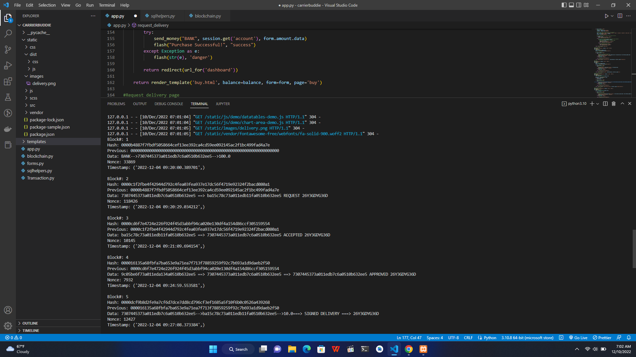

*Figure 3*

The system reflected a positive outcome as it managed to add a valid block to the blockchain after a request delivery API call.

**4.1.4 BLACK BOX TESTING**

Black box testing refers to the evaluations performed that only take into account the system’s behavior externally. Black box testing allows even an individual without the knowledge of the internal components of the system to test it against its functional and non-functional requirements .The individual can only have the knowledge of what the system must do, how to navigate around the system and operate it.

SCREENSHOTS OF SYSTEM IN BLACKBOX TESTING



*Figure 4*

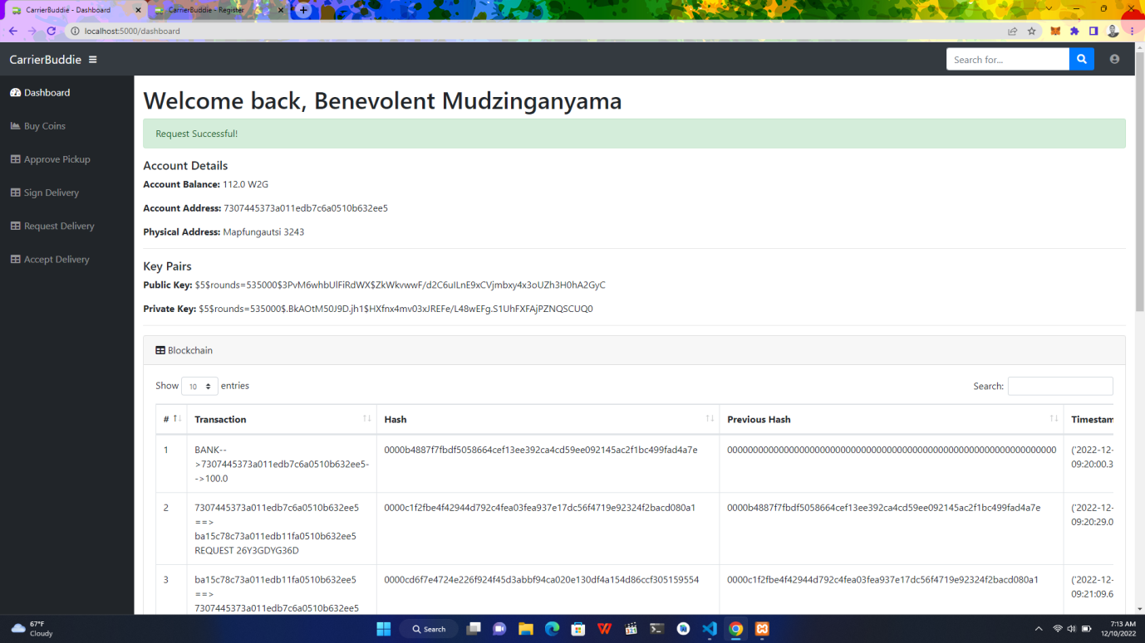

*Figure 5*



*Figure 6*

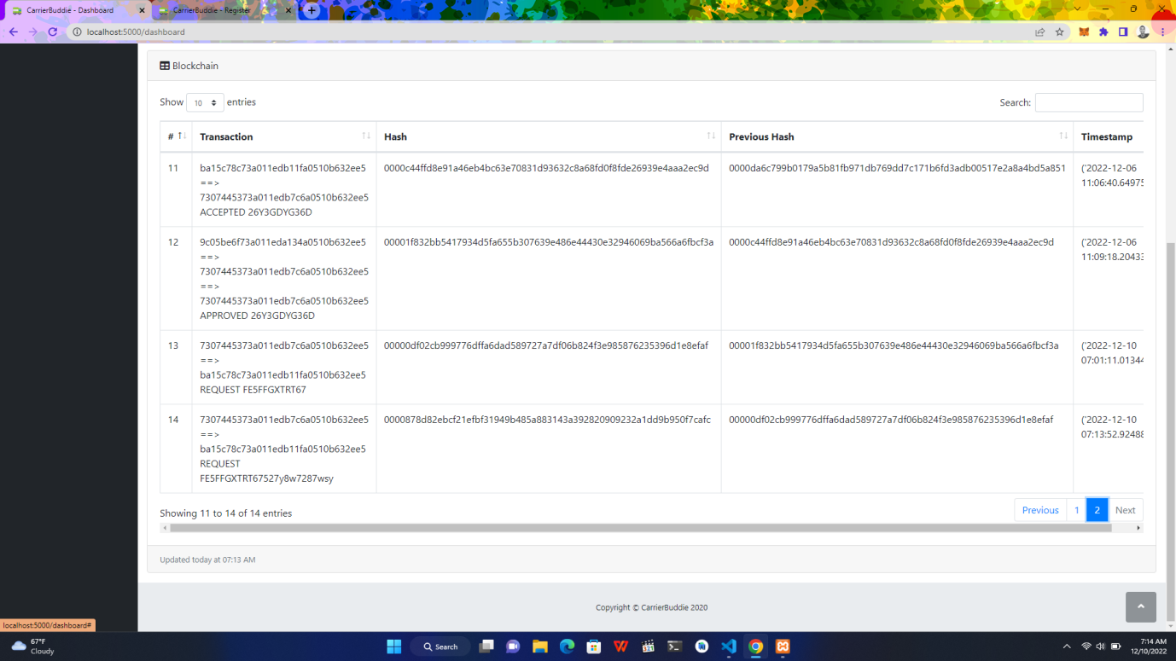

*Figure 7*

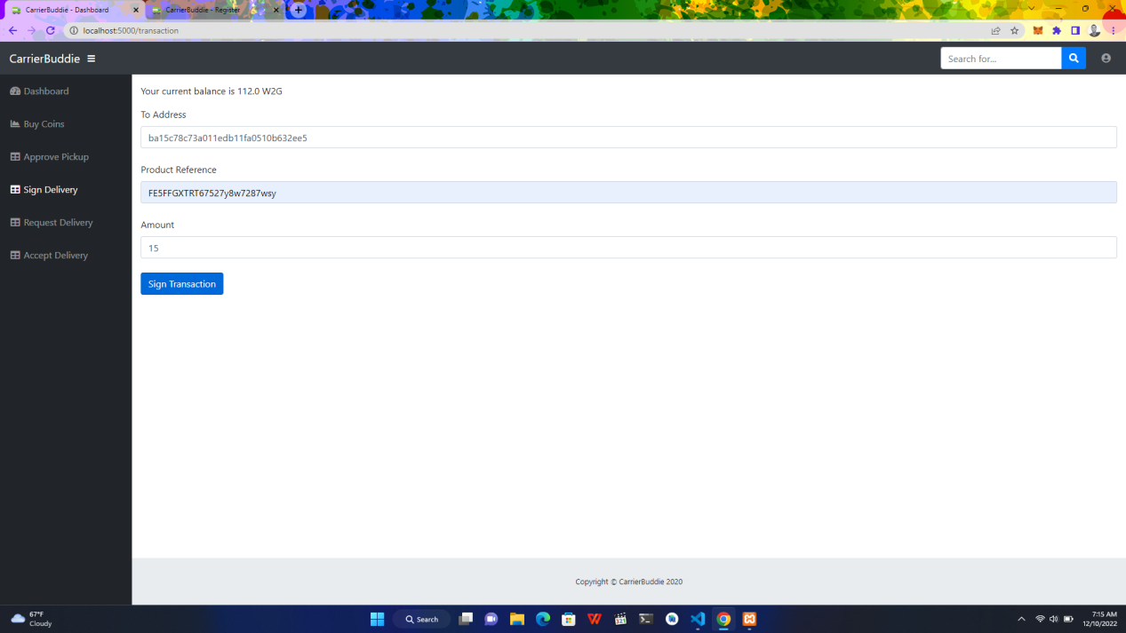

*Figure 8*

The system was able to make a blockchain aided delivery transaction. After a product is delivered to the user, it is signed by the receiver. The block is appended to the public ledger and broadcasted on the network for traceability.

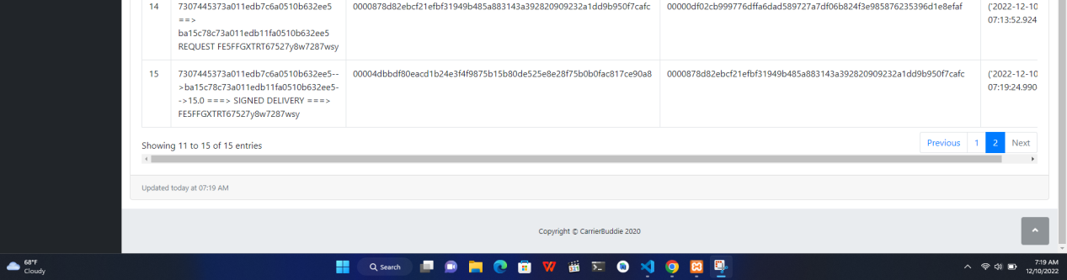

*Figure 9*

**4.2 ANALYSIS AND INTERPRETATION OF RESULTS**

**4.2.1 EVALUATION MEASURE AND RESULTS**

System evaluation includes measuring the final system against its initial performance goals as well as performing ongoing testing to see that the system continues to meet those goals. Blockchain networks rely on consensus algorithms and smart contracts to reach agreement among various distributed nodes. A consensus mechanism such as proof of work (PoW) secures the network and prevents unauthorized users from validating bad transactions. Smart contracts are self-executing contracts in which the contents of the buyer-seller agreement are inscribed directly into lines of code. The author will use these mechanisms to evaluate the system.

**4.4.2 PROOF OF WORK CONSENSUS ALGORITHM**

This consensus algorithm is used to select a miner for the next block generation. This is done by taking data from a block header as an input, and continuously running this data through a cryptographic hash function. Every time this is done, small changes are made to the input data by including an arbitrary number called a nonce. This is the blockchain version of guesswork to find a solution.

**Calculation**

P = proof

Pp = previous proof

**Proof =** Find a number p such that hash(pp') contains leading 4 zeroes, where p is the previous p'

- p is the previous proof, and p' is the new proof

**Valid Proof** = Check if a hash value satisfies the mining conditions. This function is used within the proof_of_work function.

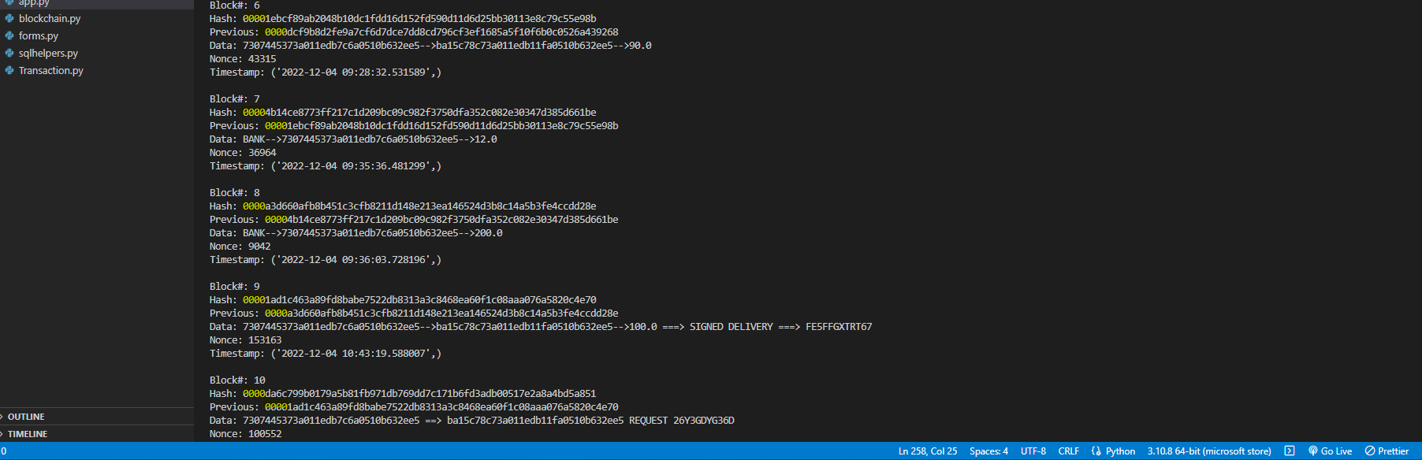

*Figure 10*

The highlighted part in the figure above show the proof of work calculated from the blocks on our blockchain network. This proves that the consensus algorithm implemented works well.

When a block is corrupted or invalid during the calculation, it is identified and removed, and the rest of the transactions after that are deemed incorrect, therefore this is where the blockchain’s distributed database system comes in, another node (server) with the correct and most recent transactions overrides every other node on the network and corrects our blockchain

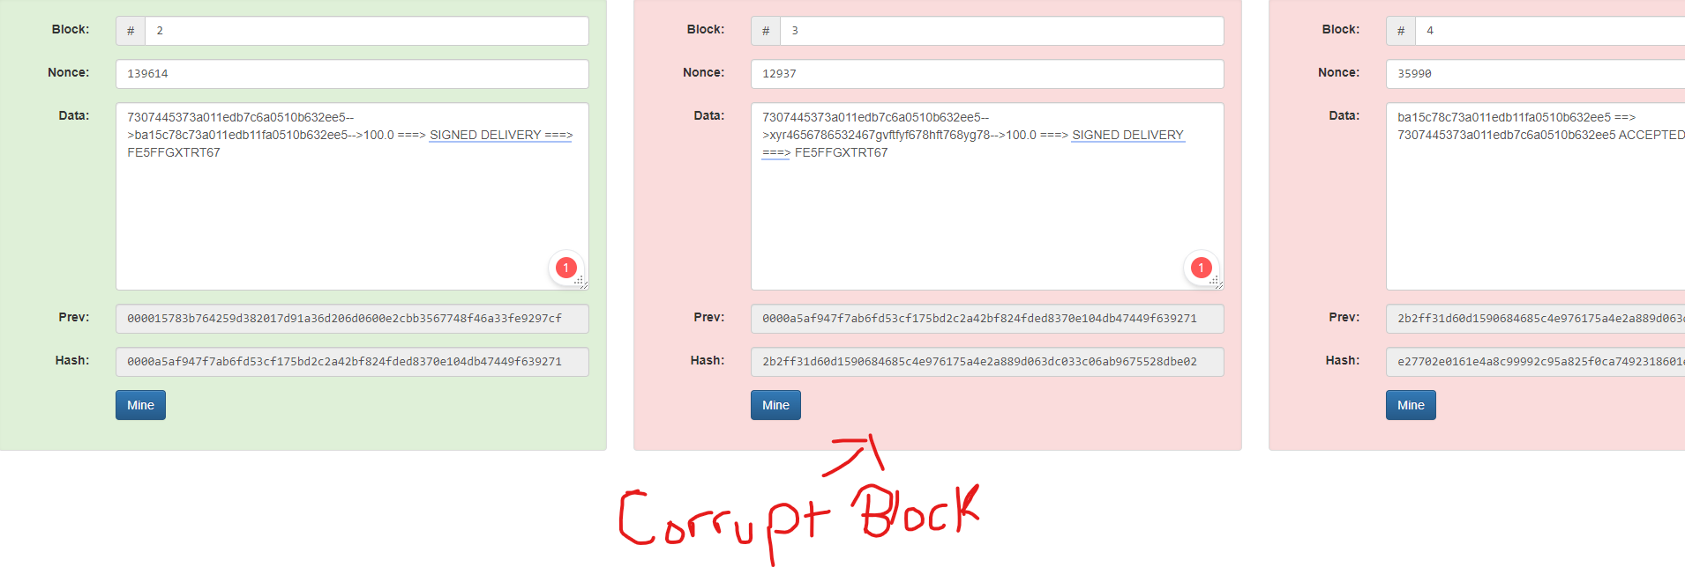

*Figure 11 : Corrupt block*

**4.4.3 SMART CONTRACTS**

Smart contracts are self-executing lines of code with the terms of an agreement between buyer and seller automatically verified and executed via a computer network. Smart contracts deployed to blockchains render transactions traceable, transparent, and irreversible.

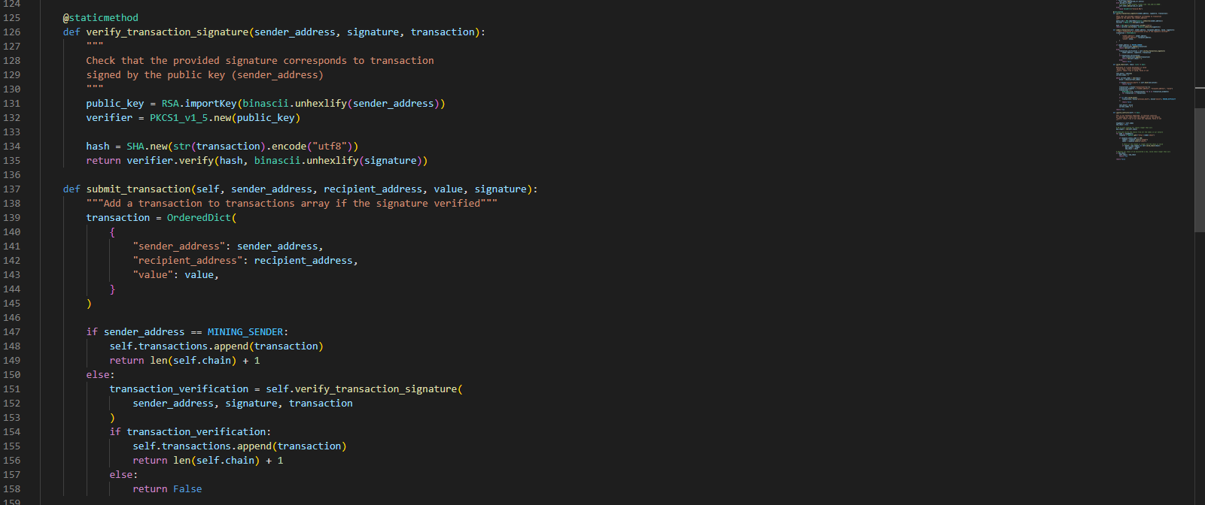

*Figure 11: Smart Contract algorithm*

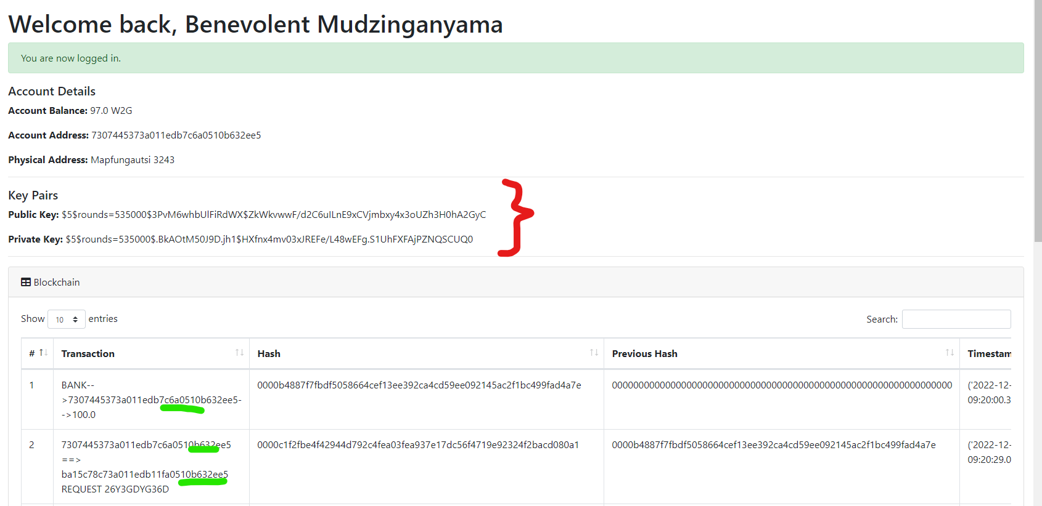

*Figure 12: Use case in our blockchain system*

**4.3 A SUMMARY OF RESEARCH FINDINGS**

**4.3.1 CONCLUSION**

The results showed that the consensus algorithm and smart contracts system implemented follow the blockchain concepts well, from handling block conflicts and verifying delivery transactions made on the system’s network. This validates the objectives of our system and answers all our research questions as described in the first chapter of this research paper.

# **CHAPTER FIVE: CONCLUSIONS AND RECOMMENDATIONS**

## **5.1 INTRODUCTION**

The author focused on the presentation and analysis of the results collected from the research on the previous chapter. Now this chapter focuses on conclusions, recommendations and future works of using blockchain in delivery and also aims to acknowledge the short comings of the proposed system. Moreover this chapter takes a view into the staggers faced by the author during the design, development and implementation of the research system under considerations.

## **5.2 MAJOR CONCULSIONS DRAWN**

## **5.2.1 AIMS AND OBJECTIVES REALIZATION**

In chapter one the author outlined the research objectives, also the main aim of this research project was to design and develop a

## **5.2.2 CONCLUSIONS**

The use of blockchain in delivery and logistics chains in general will boost transparency and traceability in an industry where these factors matters most. Also as a result this solution will relieve the financial burden for sellers facilitating deliveries on their own and will greatly improve the delivery time for products bought online.

**5.3 RECOMMENDATIONS**

It is recommended to use powerful machines to develop blockchain systems for computational advantages. The blockchain mining consumes a lot of computer resources during proof of work consensus algorithm calculations hence an exceptional machine would improve the calculation speeds and smoothen the whole process. Also the use of a more secure database to store the records of blocks added on the network to minimize general attacks.

**5.4 FUTURE WORKS**

Digitization and technological advancement are so fast that every organization like industry seeks to improve its functioning through blockchain technologies. Blockchains were primarily being heavily implemented in cryptocurrencies but they have been realized to have an infinity use cases in medicine, schools, supply chains, logistics and many more. So as more people start to understand them, they will be used almost in every case that requires the best security, transparency, traceability and trust among the participants.

## **5.5 CHALLENGES FACED**

During the research, the author faced challenges in finding the optimal machine to work with in developing the blockchain network, since the computational power required to mine blocks is high. Also the use of distributed ledgers were of a problem, implementation wise, since more servers were to be acquired to collect the same data concurrently. In overall it was not an easy task creating the proposed system, but the solution was of greater importance than the difficulties faced on the way.

## 

## **APPENDIX**

The appendix was divided into two sections:

For the E-commerce Business:

Q1: Total number of delivery locations in Zimbabwe?

………………………………………………………………………………………………………

Q2: How do you deliver products in Zimbabwe?

……………………………………………………………………………………………………………………………………………………………………………………………………………………………………………………………………………………………………………………....

Q3: How many goods do you deliver every month?

………………………………………………………………………………………………………………………………………………………………………………………………………………………………………………………………………………………………………………………

Q4: What is the average amount you charge per delivery?

………………………………………………………………………………………………………………………………………………………………………………………………………………

Q5: How long does it take you to process a delivery transaction?

……………………………………………………………………………………………………

Q6: What is the product with the highest sales at national level in Zimbabwe?

………………………………………………………………………………………………………

Q7: How often do you encounter problems when delivering a purchased item?

………………………………………………………………………………………………………………………………………………………………………………………………………………………………………………………………………………………………………………………

For Customers

Q1: How often do you shop online?

………………………………………………………………………………………………………………………………………………………………………………………………………………

Q2: Does the item arrive in time after you place your orders?

………………………………………………………………………………………………………………………………………………………………………………………………………………

Q3: Do you sometimes not get your orders delivered and what will be the reason?

………………………………………………………………………………………………………………………………………………………………………………………………………………………………………………………………………………………………………………………

Q4: How long do you have to wait to receive your order?

………………………………………………………………………………………………………………………………………………………………………………………………………………………………………………………………………………………………………………………

Q5: Has there been issues with your deliveries before, such as trust issues, lack of transparency, over pricing and less collaboration?

………………………………………………………………………………………………………………………………………………………………………………………………………………

## **REFERENCES**

Alshenqeeti, H. (2014) ‘Interviewing as a Data Collection Method: A Critical Review’, *English Linguistics Research*, 3(1). doi:10.5430/elr.v3n1p39.

Babich, V., and G. Hil Distributed Ledgers and Operations: What Operations Management Researchers Should Know About Blockchai Manufacturing & Service Operations Management (Forthcoming).

Christidis, K., and M. Devetsiki rt Contracts for the Internet of IEEE Access 4:2292-303. doi: 10.1109/ACCESS.2016.2566339.

NRI (2015) Survey on Blockchain Technologies and Related Services, Technical Report.

Omohundro, S. (2014) ‘Cryptocurrencies, smart contracts, and artificial intelligence’, AI Matters,

Vol. 1, No. 2, pp.19–21.

Buterin, V. (2015) On Public and Private Blockchains, https://blog.ethereum.org/2015/08/07/onpublic-and-private-blockchains/.

Johnson, D., Menezes, A. and Vanstone, S. (2001) ‘The elliptic curve digital signature algorithm

(ECDSA)’, International Journal of Information Security, Vol. 1, No. 1, pp.36–63.

Lamport, L., Shostak, R. and Pease, M. (1982) ‘The byzantine generals problem’, ACM Transactions

on Programming Languages and Systems (TOPLAS), Vol. 4, No. 3, pp.382–401.

Mbokane, A. (2001) ‘CHAPTER 3 Research design , research method and population’, *Convenience Sampling*, pp. 84–99. Available at: http://uir.unisa.ac.za/bitstream/handle/10500/1313/04chapter3.pdf?sequence=4.

Muhammad, S. and Kabir, S. (2016) *METHODS OF DATA COLLECTION*. Available at: https://www.researchgate.net/publication/325846997.

Nagori, V. and Trivedi, B. (2014) *Types of Expert System: Comparative Study*, *Asian Journal of Computer and Information Systems*. Available at: www.ajouronline.com.

Batta, A., Gandhi, M., Kar, A.K., Loganayagam, N. and Ilavarasan, V., 2020. Diffusion of blockchain in logistics and transportation industry: an analysis through the synthesis of academic and trade literature. Journal of Science and Technology Policy Management.

Badzar, A., 2016. Blockchain for securing sustainable transport contracts and supply chain transparency. Master’s Study, Lund University, Helsingborg, Sweden.

Muessigmann, B., von der Gracht, H. and Hartmann, E., 2020. Blockchain technology in logistics and supply chain management—A bibliometric literature review from 2016 to January 2020. IEEE transactions on engineering management, 67(4), pp.988-1007.

Zhou, Z., Wang, M., Huang, J., Lin, S. and Lv, Z., 2021. Blockchain in big data security for intelligent transportation with 6G. IEEE Transactions on Intelligent Transportation Systems.

Zheng, Z., Xie, S., Dai, H.N., Chen, X. and Wang, H., 2018. Blockchain challenges and opportunities: A survey. International journal of web and grid services, 14(4), pp.352-375.

Dobrovnik, M., Herold, D.M., Fürst, E. and Kummer, S., 2018. Blockchain for and in Logistics: What to Adopt and Where to Start. Logistics, 2(3), p.18.

Humayun, M., Jhanjhi, N.Z., Hamid, B. and Ahmed, G., 2020. Emerging smart logistics and transportation using IoT and blockchain. IEEE Internet of Things Magazine, 3(2), pp.58-62.

Ahmad, F., Ahmad, Z., Kerrache, C.A., Kurugollu, F., Adnane, A. and Barka, E., 2019, April. Blockchain in internet-of-things: Architecture, applications and research directions. In 2019 International conference on computer and information sciences (ICCIS) (pp. 1-6). IEEE.

Miraz, M.H., Hye, A.M., Alkurtehe, K.A.M., Habib, M., Ahmed, S., Molla, M.S. and Hasan, M.T., 2020. The effect of blockchain in transportation Malaysia. International Supply Chain Technology Journal, 6(01).

Wang, X. and Shi, H., 2018, December. Research on container transportation application based on blockchain technology. In Proceedings of the Asia-Pacific Conference on Intelligent Medical 2018 & International Conference on Transportation and Traffic Engineering 2018 (pp. 277-281).